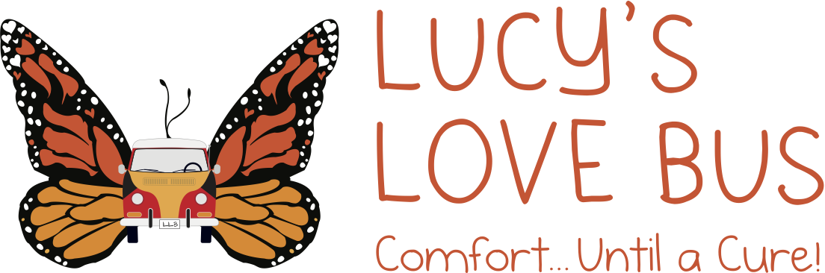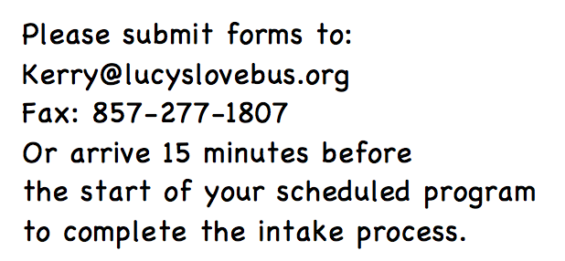
Lucy’s Love Bus Participant Information for Sajni Center programs

Referring organization: ___________________________

Adult or Parent #1: ______________________________ Phone: _____________
Preferred pronouns (circle) He/him She/her They/them
Address: ___________________________________________________________
City: __________________________ State: __________ Zip code: ____________
Email Address: ________________________________________________
Diagnosis (if applicable): ____________________________________________
Allergies: _________________________________________________________
Current Medications: _______________________________________________
Other notes: ____________________________________________________________

______________________________________________________________________

Adult or Parent #2 Name: __________________________ Phone: ________________
Relationship to Adult or Parent #1: __________________________
Email Address: ________________________________________________
Preferred pronouns (circle) He/him She/her They/them
Diagnosis (if applicable): ____________________________________________
Allergies: _________________________________________________________
Current Medications: _______________________________________________
Other notes: ____________________________________________________________

______________________________________________________________________

Child #1 Name: _________________________________ DOB:___________
Preferred pronouns (circle) He/him She/her They/them
Relationship to Adult or Parent #1: __________________________
Relationship to Adult or Parent #2: __________________________
Grade: ____________________ School: __________________________
Diagnosis (if applicable): ____________________________________________
Allergies: _________________________________________________________
Current Medications: _______________________________________________
Other notes: ____________________________________________________________

______________________________________________________________________

Child #2 Name: _________________________________ DOB:___________
Preferred pronouns (circle) He/him She/her They/them
Relationship to Adult or Parent #1: __________________________
Relationship to Adult or Parent #2: __________________________
Grade: ____________________ School: __________________________
Diagnosis (if applicable): ____________________________________________
Allergies: _________________________________________________________
Current Medications: _______________________________________________
Other notes: ____________________________________________________________

______________________________________________________________________

Child #3 Name: _________________________________ DOB:___________
Preferred pronouns (circle) He/him She/her They/them
Relationship to Adult or Parent #1: __________________________
Relationship to Adult or Parent #2: __________________________
Grade: ____________________ School: __________________________
Diagnosis (if applicable): ____________________________________________
Allergies: _________________________________________________________
Current Medications: _______________________________________________
Other notes: ____________________________________________________________
______________________________________________________________________

Please carefully read, review, and initial the below agreement in order to participate in programs through Lucy’s Love Bus to ensure the safety and comfort of all participants.
o _______ No family member or attendee will visit The Sajni Center if they have been sick in the past 24 hours, are feeling ill, have been exposed to a virus, or do not have the appropriate age required immunizations.
o _______ All parents are to remain at The Sajni Center during programs.
o _______ (If children are attending under your care): My children are up to date on all vaccinations and I will provide a copy of my children’s immunization records prior to attending any programs. (Children who are being treated for cancer often have severely compromised immune systems, so we are required to collect this information for their safety. All medical information will be stored in a HIPAA-compliant manner.)

LUCY’S LOVE BUS CHARITABLE TRUST, INC.

RELEASE AND AGREEMENT

The undersigned adults, parent(s) and/or guardian(s) (hereinafter “Adult(s)”) have requested the assistance of Lucy’s Love Bus Charitable Trust, Inc. and its respective volunteers, officers, directors, employees and agents (collectively “Lucy’s Love Bus”) in identifying providers (hereinafter “Provider(s)”) of services including, but not limited to, acupuncture, massage, therapeutic horseback riding, Reiki, meditation, tai chi, art, music and dance therapist, and medical support (collectively “services”), so that such Providers can render their services to the Adult(s) and/or their minor child(ren) ___________________________________________________________ (hereinafter “Child”) in their home, the hospital, provider’s office, or The Sajni Center of Lucy’s Love Bus.

Adult(s) hereby acknowledge and understand that Lucy's Love Bus makes referrals only to Providers who are licensed and insured in their respective fields, as applicable. Adult(s), however, understand that Adult(s) are ultimately wholly responsible for, and assume the entire risk of, determination as to whether a Provider and/or Provider services are safe and proper for them/their Child. Such determination includes, but is not limited to, whether a Provider is qualified to perform services for them/Child. Adult(s) further acknowledge and understand that Adult(s) should consult with their and/or their Child’s medical professionals as to whether Provider’s services could potentially harm them/their Child. Adult(s) also acknowledge and understand that Provider’s services may have the potential to contain inherent risks which could lead to injuries or even death of them/their Child, under rare circumstances.

In consideration of Lucy’s Love Bus’s identification of Providers:

1. ADULT(S) HEREBY FULLY ASSUME THE RISKS INHERENT IN PROVIDER SERVICES. After consideration of the risks inherent in Provider’s services, including but not limited to, those addressed above, Adult(s) hereby fully assume any and all risks associated with Adult(s)’ and/or Child’s participation in any and all Provider services.

2. ADULT(S) HEREBY WAIVE ANY AND ALL CLAIMS AGAINST LUCY’S LOVE BUS. Adult(s) further agree to waive and release any and all claims that Adult(s), Child, or their respective heirs, have, or may have in the future, against Lucy's Love Bus for any losses, damages, expenses, or injuries, including death, suffered from, or in connection with, Adult(s)’ and/or Child’s participation in any and all Provider services.

3. ADULT(S) HEREBY INDEMNIFY AND HOLD HARMLESS LUCY’S LOVE BUS. Adult(s) hereby promise to indemnify, reimburse, defend, and hold harmless Lucy's Love Bus against any and all legal claims and proceedings of any description that may have been asserted in the past, or may be asserted in the future, directly, including damages, costs and attorney’s fees, arising from personal injuries to Adult(s) and/or Child resulting from participation in any and all Provider services.
4. ADULT(S) HEREBY AGREE TO ARBITRATION IN THE EVENT OF A DISPUTE. In the event a dispute shall arise between Adult(s) and Lucy's Love Bus, Adult(s) hereby agrees that any and all such disputes shall be referred to a mutually agreed upon arbitrator for arbitration in accordance with the applicable American Arbitration Association Commercial Rules of Arbitration. Adult(s) agrees that such arbitration shall be the agreed upon dispute resolution of all matters between the Parties of this Agreement. In the event that the Adult(s) and Lucy's Love Bus cannot agree on a single arbitrator each part shall appoint an arbitrator and those chosen arbitrators shall, in turn, agree on a third arbitrator for a complete panel of three arbitrators. The dispute(s) shall then be resolved by the single chosen arbitrator or the panel and any decision by the arbitrator or the panel shall be final and legally binding and judgment may be entered thereon.

Each part shall be responsible for its share of costs associated with arbitration. In the event a party fails to proceed with arbitration, unsuccessfully challenges the arbitrator’s award, or fails to comply with the arbitrator’s award, the other part is entitled to costs of legal suit, including reasonable attorney’s fees for having to compel arbitration or defend or enforce the award.

5. ADULT(S) HEREBY AUTHORIZE AND CONSENT TO CHILD’S PARTICIPATION IN PROVIDER’S SERVICES. After consideration of the risks inherent in participating in Provider(s)’ services, Adult(s) hereby consent to, and authorize, Child’s participation in any and all such services.

Adult(s) acknowledge reading, understanding, and agreeing to the above Paragraphs including, but not limited to, those numbered one through six (1 – 6) and sign below to bind themselves, their minor children, their (and their children’s) heirs, successors, assigns and estates to the conditions described therein. Adult(s) agree that this document is an accurate understanding and has not been modified orally.

___________________________________ ________________________________
Parent/Guardian or Adult 18+ Printed Name Parent/Guardian or Adult 18+ Signature

___________________________________
Date

Photo/Video Release
I consent ___ / do not consent ____ (please mark one) and authorize the use and reproduction by Lucy’s Love Bus of any and all photographs and any other audio-visual materials taken of me for promotional material, educational activities, exhibitions or for any other use for the benefit of the organization. We do not share last names, diagnosis, or hometowns unless given explicit permission in order to protect privacy.

Adult Printed Name:

______________________________________________________________

Signature:______________________________________ Date: _______________

