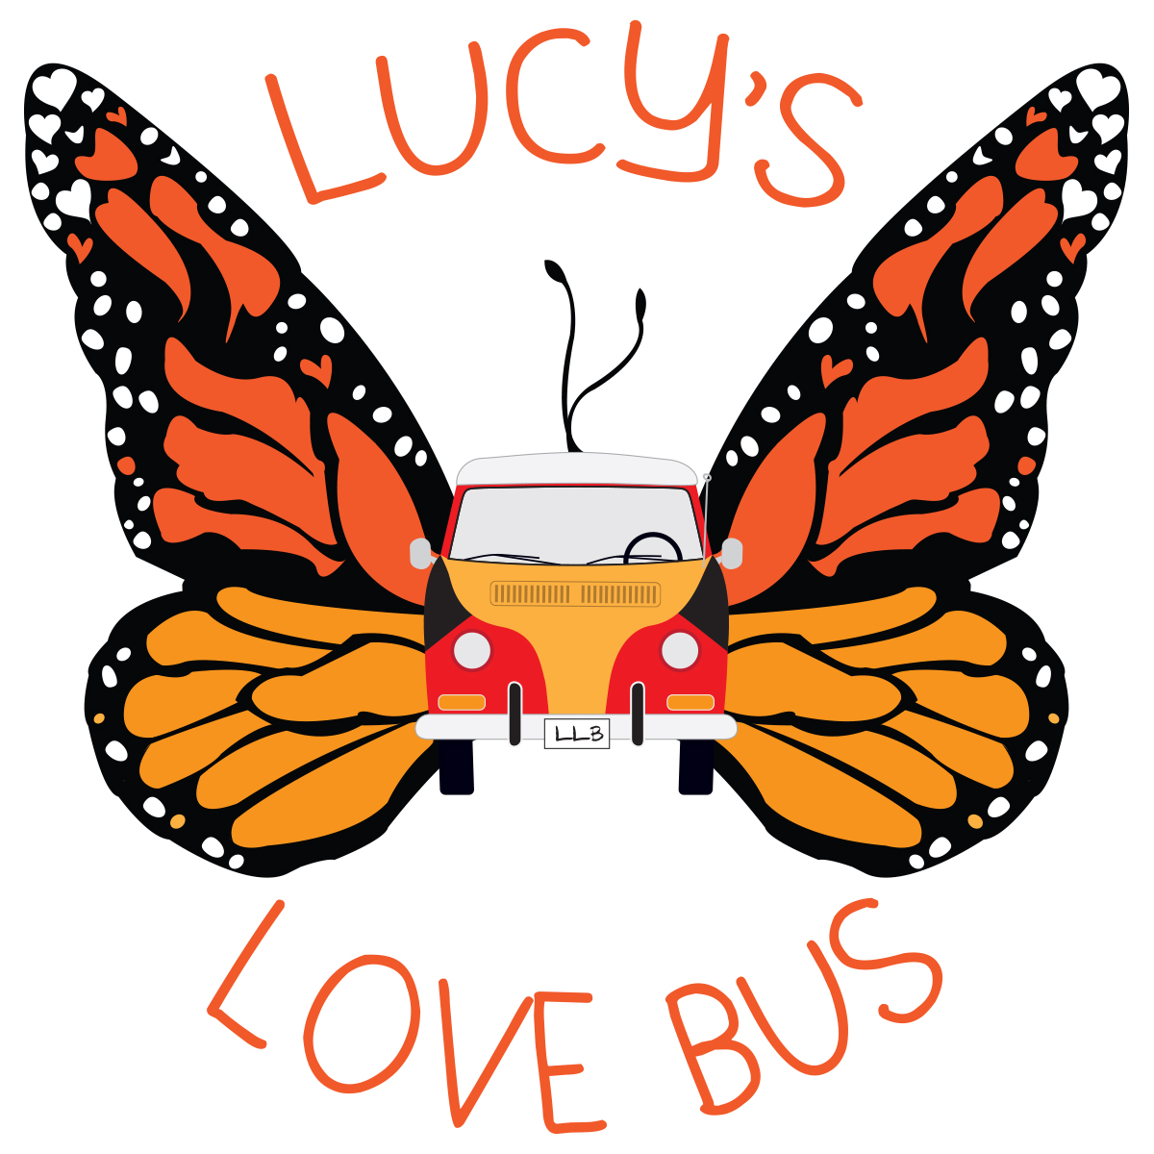

Lucy’s Love Bus

Delivering Comfort... Until A Cure.

Sajni’s Siblings Application – Funding for Integrative Therapies

The Mission
Our Sajni’s Siblings program embraces the siblings of children with cancer through opportunities to create happy memories during a very lonely and difficult time. This program augments our Lucy’s Children program so that the sick child and their sibling(s) can participate in integrative therapies and activities together to facilitate bonding time outside of the hospital or home or provides the sibling(s) with a chance to engage in a solo activity focused on their own needs and fulfillment. This program also supports bereaved siblings, allowing them a chance to participate in an activity to support them in the grieving process.

Siblings of Lucy’s Love Bus children will be awarded $500 in funding for their chosen integrative therapy, with another $250 available per additional sibling. These are currently available as one-time grants.
Restrictions: siblings can participate at the same location as their sibling (but can be a different time/session/class), can participate with one of our existing partners, or can go somewhere that will accept payment by American Express.

Demographic information
This optional information is collected so that we can accurately measure the impact of our services.
This information is confidential and will only be shared as a dataset, with no specific tie of your submitted data to your name/personal information. Thank you for helping us collect this important information.

Contact information

Parent/Guardian Name: ____________________________________________________

Relationship to children (circle): Mother Father Other: ______________________

Phone number with area code: __________________________________ ☐ Cell ☐ Home

Email: _____________________________________________________

Preferred method of communication?
☐ Text my CELL ☐ Call my CELL ☐ HOME PHONE ☐ EMAIL

Home Address: _____________________________________________________

_____________________________________________________

Name of child with (history of) cancer: ________________________________________________

Is this child receiving funding from Lucy’s Love Bus?
☐ Yes ☐ No, but is interested ☐ No, not interested ☐ Child has passed

Sibling #1 name: ________________________________________________

Date of Birth: ________________________________________________

Pronouns ☐ He/him/his ☐She/her/hers ☐They/them/theirs ☐ Other: __________
☐ Would like to participate in activity with sibling.
☐ Would like to participate at same location, but not with sibling.
Name of business: __________________________
☐ Would like to participate in another activity.
Do you already know where you’d like to go? ☐ Yes ☐ No

If yes, please list name of business, and contact info if available: _____________________________________
_________________________________________________________________________________________
If no, please circle preferred activity:
Massage Acupuncture Horseback riding Yoga
Chiropractic care Art therapy/classes Reiki Music therapy/lessons
Swimming lessons Gym membership/personal training Gymnastics Dance
Other: ________________
Please share any diagnoses or other notes: __________________________________________________
__________________________________________________________________________________________________________________________________________________________________________

Child’s Ethnicity (select all that apply)

☐ Asian or Asian American

☐ Black or African American

☐ Caucasian or white

☐ Hispanic, Latinx, or Spanish Origin

☐ Middle Eastern or North African

☐ Native American, American Indian, or Alaska Native

☐ Native Hawaiian or Pacific Islander

☐ Mixed

☐ Different identity: please specify _______________
Please check the box below if sibling #1 identifies as/with:
☐ non-binary, genderqueer, transgender, or third gender

☐ LGBTQIA+
☐ having a disability and/or disabled
☐ neurodivergent

Sibling #2 name: ________________________________________________

Date of Birth: ________________________________________________

Pronouns ☐ He/him/his ☐She/her/hers ☐They/them/theirs ☐ Other: __________
☐ Would like to participate in activity with sibling.
☐ Would like to participate at same location, but not with sibling.
Name of business: __________________________
☐ Would like to participate in another activity.
Do you already know where you’d like to go? ☐ Yes ☐ No

If yes, please list name of business, and contact info if available: _____________________________________
_________________________________________________________________________________________

If no, please circle preferred activity:
Massage Acupuncture Horseback riding Yoga
Chiropractic care Art therapy/classes Reiki Music therapy/lessons
Swimming lessons Gym membership/personal training Gymnastics Dance
Other: ________________
Please share any diagnoses or other notes: __________________________________________________
__________________________________________________________________________________________________________________________________________________________________________

Child’s Ethnicity (select all that apply)

☐ Asian or Asian American

☐ Black or African American

☐ Caucasian or white

☐ Hispanic, Latinx, or Spanish Origin

☐ Middle Eastern or North African

☐ Native American, American Indian, or Alaska Native

☐ Native Hawaiian or Pacific Islander

☐ Mixed

☐ Different identity: please specify _______________

Please check the box below if sibling #1 identifies as/with:
☐ non-binary, genderqueer, transgender, or third gender

☐ LGBTQIA+
☐ having a disability and/or disabled
☐ neurodivergent

To apply for more than 2 siblings, please copy and paste as many of the above sections as needed, or contact us so we may collect information for all siblings.

Our Process

Once we receive the completed application for your child, we will confirm receipt and discuss current options for funding. Please allow up to one week for initial contact after you submit your application.

By accepting funding from Lucy’s Love Bus, you agree to participate in one brief annual survey so that we can assess our programs. This survey is conducted by email or phone, consists of 5 questions, and takes less than 5 minutes to complete. We appreciate your support in capturing the benefits of our work together. Thank you!

Guardian Signature: ___________________________________________ Date: _____________

Please let us know how you heard about us:

Our social worker Our doctor Friend/Family Internet search Social media Other: ___________________

Submit materials by:
Email: Kerry@LucysLoveBus.org |fax: (978) 517-1567 | mail: PO Box 464, Amesbury MA 01913
Questions? Call Kerry Powlovich, Program Manager
at (781) 454-8535 or email Kerry@LucysLoveBus.org.

Lucy’s Love Bus services during the Coronavirus (COVID-19) Pandemic

Lucy’s Love Bus strongly encourages all practitioners and families to follow current CDC guidelines for mitigating Coronavirus (COVID-19) exposure. Due to the weakened immune systems of many children with cancer, we advise all families to consider virtual options as able. It is ultimately up to the discretion of the parents/guardians as to their child’s wellbeing in receiving in-person services.

Therefore, parents/guardians of all children who are receiving services paid for by Lucy’s Love Bus are asked to take the following into consideration, and sign the following waiver below.

Before any appointment for service, both practitioner and each family member in attendance should answer “NO” to all following questions.

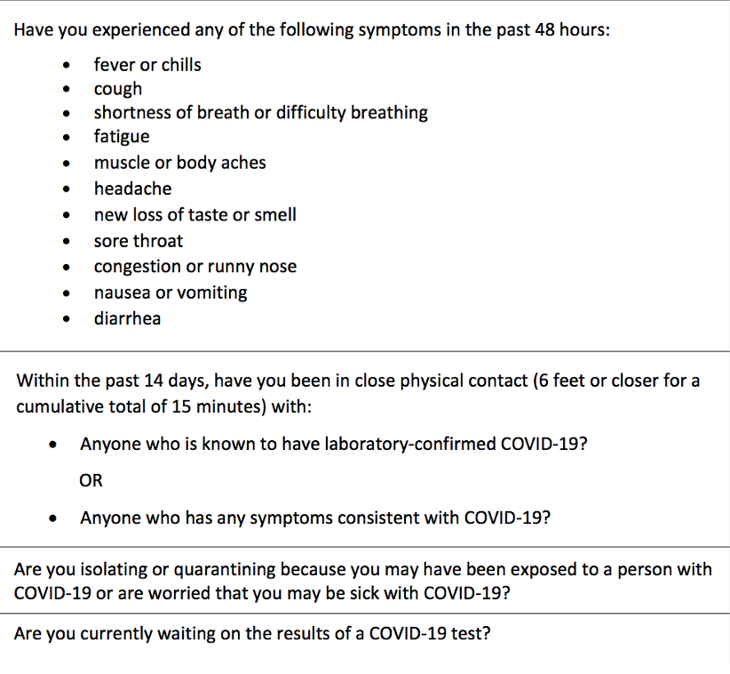

If either party answers “YES” to any of these questions, Lucy’s Love Bus strongly encourages the session to be postponed until both parties are healthy and can safely answer “NO” to all questions.

Practitioners are encouraged to share their own COVID19 protocols and procedures with families, and following updated CDC guidelines is strongly recommended.

By moving forward with services, Lucy’s Love Bus families and partnering practitioners acknowledge their own liability and potential exposure risks to COVID19 and other potential sickness.

_________________________________________________________ ____________________________
Guardian Signature Date

Please call Kerry Powlovich at (781) 454-8535 with any questions.

HIPAA NOTICE OF PRIVACY POLICIES

This notice describes how your medical information may be used and disclosed and how your privacy is being protected at our non-profit organization. The privacy of your medical information is important to us and we are committed to protecting your medical information. We create a record of the care and services that are funded through our organization to provide you with quality care and to comply with certain legal requirements. In order to maintain the level of service that you expect from our organization, we may need to share limited personal medical information. This notice will also describe your rights and certain duties we have regarding the use and disclosure of medical information.

How Our Organization May Use or Disclose Your Health Information
Our organization collects health information about your child and stores it in a secure, HIPAA compliant online file. Your medical record is the property of our organization, but the information in the medical record belongs to you. The law permits us to use or disclose your health information for the following purposes:

Treatment: We disclose your child’s medical information to our partnering integrative practitioners, employees and others who are involved in providing the care you need. For example, we may share your child’s medical information with other physicians, health care providers or other health care facilities that will provide services that we do not provide. We may disclose medical information to family or others who can help you when you are sick or injured.

Health Care Operations & Payment: We use and disclose medical information about your child to obtain funding for the services we provide. For example, we may use and disclose this information to review and improve quality of care, or to report in the aggregate to our funders. (Your child’s name will NOT be used.)

Appointment Reminders: We may use and disclose medical information to contact and remind you about appointments. If you are not home, we may leave this information on your answering machine or in a message left with the person answering the phone.

Notification & Communication with Family: We may disclose your child’s health information to notify or assist in notifying a family member, your personal representative or another person responsible for your child’s care about your child’s location, your child’s general condition or in the event of your child’s death. We may also disclose information to someone who is involved with your child’s care or helps pay for your child’s care. If you are unable or unavailable to agree or object on behalf of your child, our health professionals will use their best judgment in communication with your family and others.

Required by Law: We will limit our use and disclosure of your child’s health information to relevant requirements of the law. When the law requires us to report abuse, neglect, domestic violence, or respond to judicial or administrative proceedings, or to law enforcement officials, we will further comply with the requirement set forth below concerning those activities.

Public Health: We may, and are sometimes required by law to disclose your child’s health information to public health authorities for purposes related to: preventing or controlling disease, injury or disability; reporting child, elder or dependent adult abuse or neglect; reporting domestic violence; reporting to the Food and Drug Administration problems with products and reactions to medications; and reporting disease or infection exposure. When we report suspected elder or dependent adult abuse or domestic violence, we will inform you or your personal representative promptly unless in our best professional judgment, we believe the notification would place your child at risk of serious harm or would require informing a personal representative we believe is responsible for the abuse or harm.

Judicial and Administrative Proceedings: We may, and are sometimes required by law, to disclose your child’s health information in the course of any administrative or judicial proceeding to the extent expressly authorized by a court or administrative order. We may also disclose information about your child in response to a subpoena, discovery request or other lawful process if reasonable efforts have been made to notify you of the request and you have not objected, or if your objections have been resolved by a court or administrative order.

Law Enforcement: We may, and are sometimes required by law, to disclose your child’s health information to a law enforcement official for purposes such as identifying of locating a suspect, fugitive, material witness or missing person, complying with a court order, warrant, grand jury subpoena and other law enforcement purposes.

Public Safety: We may, and are sometimes required by law, to disclose your child’s health information to appropriate persons in order to prevent or lessen a serious and imminent threat to the health or safety of a particular person or the general public.

When Our Organization May Not Use or Disclose Your Health Information
Our organization will not use or disclose health information that identifies your child without your written authorization except as described in this Notice of Privacy Polices. If you do authorize our organization to use or disclose your child’s health information for another purpose, you may revoke your authorization in writing at any time.

Your Health Information Rights
Right to Request Special Privacy Protections: You have the right to request restrictions on certain uses and disclosures of your child’s health information, by a written request specifying what information you want to limit and what limitations on our use or disclosure of that information you wish to have imposed. We reserve the right to accept or reject your request, and will notify you of our decision.

Right to Request Confidential Communications: You have the right to request that you receive your child’s health information in a specific way or at a specific location. For example, you may ask that we send information to a particular email account or to your work address. We will comply with all reasonable requests submitted in writing which specify how or where you wish to receive these communications.

Right to Inspect and Copy: You have the right to inspect and copy your child’s health information with limited exceptions. To access your medical information, you must submit a written request detailing what information you want access to and whether you want to inspect or copy the record. We will charge a reasonable fee, as allowed by Massachusetts law. We may deny your request under limited circumstances.

Changes to this Notice of Privacy Practices
We reserve the right to amend this Notice of Privacy Practices at any time in the future. Until such amendment is made, we are required by law to comply with this Notice. After an amendment is made, the revised Notice of Privacy Protections will apply to all protected health information that we maintain, regardless of when it was created or received.

Questions and Complaints
Questions and complaints about this Notice of Privacy Practices or how our organization handles your health information should be directed to our Executive Director during regular business hours. If you are not satisfied with the manner in which our organization handles a complaint, you may submit a formal complaint without the risk of penalization to: Department of Health and Human Services, Office of Civil Rights, Hubert H. Humphrey Bldg., 200 Independence Avenue, S.W., Room 509F HHH Building, Washington, DC 20201.

PRIVACY POLICIES ACKNOWLEDGEMENT
I have received, read and understood the Notice of Privacy Policies of our organization. I understand how Lucy’s Love Bus Charitable Trust may use or disclose my child’s health information. I understand when Lucy’s Love Bus Charitable Trust may not use or disclose my health information. I understand my child’s health information rights and understand that Lucy’s Love Bus Charitable Trust reserves the right to change this Notice of Privacy Practices. I also understand how to place a complaint regarding this Notice and have also been provided the opportunity to review and question the privacy policies of Lucy’s Love Bus Charitable Trust.

_____________________________________________ ________________________
Signature of Patient or Authorized Representative ^{Date}

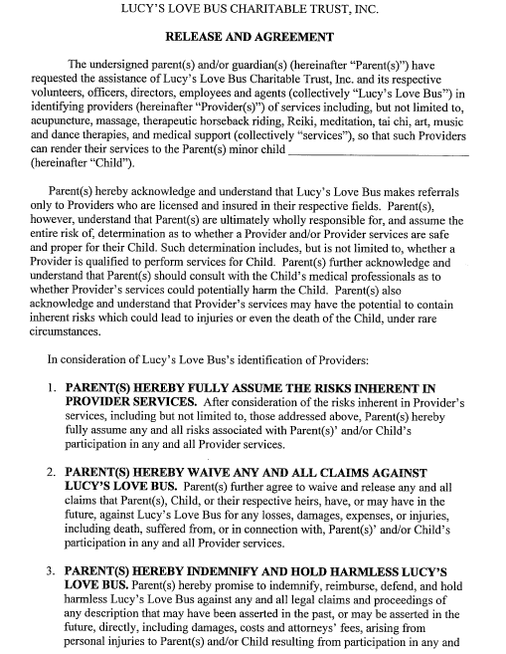
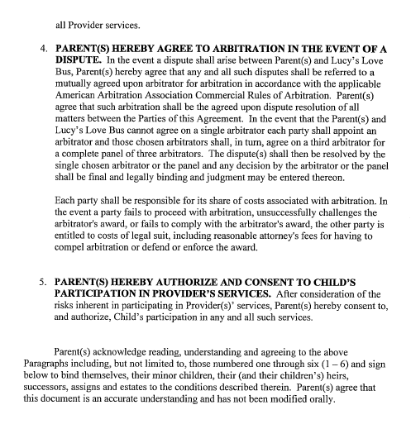

_________________________________ ____________________________________
Parent/Guardian Printed Name Parent/Guardian Signature

__________________________________
Date

